Parallelism Conditions

Definition
# Source: AI Source: Provided by: [Data Path: Persons Table -> ID Column: 1, Name_En Column: Motasem Essam] -> From: [ChatGPT] on [7/25/2026]
Parallelism Conditions are geometric conditions that require two or more geometric objects to have a prescribed parallel relationship.
In Euclidean geometry, two distinct coplanar lines are parallel when they do not intersect, meaning they remain the same distance apart.
For two distinct lines $l_{1}$and $l_{2}$:
$$\boxed{l_{1}∥l_{2}}$$
is the fundamental parallelism condition.
Parallelism can apply to:
- lines
- line segments
- rays
- planes
- sides of polygons
- corresponding geometric elements
- lines and planes in 3D geometry

Simple Definition
# Source: AI Source: Provided by: [Data Path: Persons Table -> ID Column: 1, Name_En Column: Motasem Essam] -> From: [ChatGPT] on [7/25/2026]
A Parallelism Condition is a geometric requirement that two geometric objects have the same direction or remain parallel without intersecting.
Example:
$$\boxed{AB∥CD}$$
means segment $AB$is parallel to segment $CD$.

Classification of Parallelism Conditions
# Source: AI Source: Provided by: [Data Path: Persons Table -> ID Column: 1, Name_En Column: Motasem Essam] -> From: [ChatGPT] on [7/25/2026]
A practical classification is:
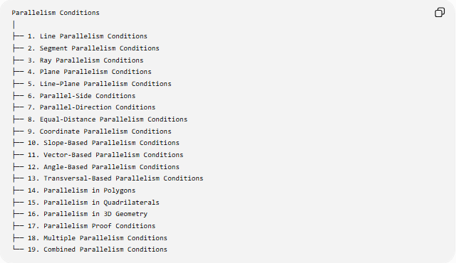
Parallelism Conditions
│
├── 1. Line Parallelism Conditions
├── 2. Segment Parallelism Conditions
├── 3. Ray Parallelism Conditions
├── 4. Plane Parallelism Conditions
├── 5. Line–Plane Parallelism Conditions
├── 6. Parallel-Side Conditions
├── 7. Parallel-Direction Conditions
├── 8. Equal-Distance Parallelism Conditions
├── 9. Coordinate Parallelism Conditions
├── 10. Slope-Based Parallelism Conditions
├── 11. Vector-Based Parallelism Conditions
├── 12. Angle-Based Parallelism Conditions
├── 13. Transversal-Based Parallelism Conditions
├── 14. Parallelism in Polygons
├── 15. Parallelism in Quadrilaterals
├── 16. Parallelism in 3D Geometry
├── 17. Parallelism Proof Conditions
├── 18. Multiple Parallelism Conditions
└── 19. Combined Parallelism Conditions

Line Parallelism Conditions
# Source: AI Source: Provided by: [Data Path: Persons Table -> ID Column: 1, Name_En Column: Motasem Essam] -> From: [ChatGPT] on [7/25/2026]
Definition
A Line Parallelism Condition requires two distinct lines in the same plane to be parallel.
$$\boxed{l_{1}∥l_{2}}$$
Example
If two railway tracks extend in the same direction without meeting:
$$\boxed{l_{1}∥l_{2}}$$
Important property
For distinct parallel lines:
$$l_{1}∩l_{2}=∅.$$
They do not have a common point in Euclidean geometry.

Segment Parallelism Conditions
# Source: AI Source: Provided by: [Data Path: Persons Table -> ID Column: 1, Name_En Column: Motasem Essam] -> From: [ChatGPT] on [7/25/2026]
Definition
A Segment Parallelism Condition requires two line segments to lie on parallel lines.
For example:
$$\boxed{\overset{‾}{AB}∥\overset{‾}{CD}}$$
means the supporting lines of $AB$and $CD$are parallel.
Example
In a parallelogram $ABCD$:
$$\boxed{AB∥CD}$$
and:
$$\boxed{BC∥AD}.$$
Important distinction
Two finite segments do not need to be the same length to be parallel.
For example:
$$AB=5, CD=10$$
can still satisfy:
$$AB∥CD.$$

Ray Parallelism Conditions
# Source: AI Source: Provided by: [Data Path: Persons Table -> ID Column: 1, Name_En Column: Motasem Essam] -> From: [ChatGPT] on [7/25/2026]
Definition
A Ray Parallelism Condition requires two rays to have parallel supporting lines and compatible directions.
Example:
$$\vec{AB}∥\vec{CD}.$$
Direction consideration
For rays, direction can matter.
The supporting lines may be parallel even when the rays point in opposite directions.
Thus it is useful to distinguish:
- parallel supporting lines
- same-direction rays
- opposite-direction rays

Plane Parallelism Conditions
# Source: AI Source: Provided by: [Data Path: Persons Table -> ID Column: 1, Name_En Column: Motasem Essam] -> From: [ChatGPT] on [7/25/2026]
Definition
A Plane Parallelism Condition specifies that two planes in three-dimensional space do not intersect.
$$\boxed{Π_{1}∥Π_{2}}$$
Example
The floor and ceiling of a room can be modeled as parallel planes:
$$\boxed{Π_{\text{floor}}∥Π_{\text{ceiling}}}.$$
Coordinate/vector condition
Two planes are parallel when their normal vectors are parallel.
If:
$$n_{1}∥n_{2},$$
then their planes have parallel orientations.

Line–Plane Parallelism Conditions
# Source: AI Source: Provided by: [Data Path: Persons Table -> ID Column: 1, Name_En Column: Motasem Essam] -> From: [ChatGPT] on [7/25/2026]
Definition
A Line–Plane Parallelism Condition occurs when a line does not intersect a plane.
$$\boxed{l∥Π}$$
Example
A horizontal line drawn above a horizontal plane can satisfy:
$$l∥Π.$$
Vector condition
If $v$is the direction vector of the line and $n$is the normal vector of the plane:
$$\boxed{v⋅n=0}$$
means the line's direction is parallel to the plane.
However, the line must not lie in the plane if we specifically require $l∥Π$rather than $l⊂Π$.

Parallel-Side Conditions
# Source: AI Source: Provided by: [Data Path: Persons Table -> ID Column: 1, Name_En Column: Motasem Essam] -> From: [ChatGPT] on [7/25/2026]
Definition
A Parallel-Side Condition specifies that sides of a polygon are parallel.
Example: parallelogram
For parallelogram $ABCD$:
$$\boxed{AB∥CD}$$
and:
$$\boxed{BC∥AD}.$$
Example: trapezoid
A trapezoid has at least one pair of parallel sides.
For trapezoid $ABCD$:
$$\boxed{AB∥CD}.$$

Parallel-Direction Conditions
# Source: AI Source: Provided by: [Data Path: Persons Table -> ID Column: 1, Name_En Column: Motasem Essam] -> From: [ChatGPT] on [7/25/2026]
Definition
A Parallel-Direction Condition requires geometric objects to have the same or parallel direction.
For vectors:
$$\boxed{\vec{u}∥\vec{v}}$$
means one vector is a scalar multiple of the other:
$$\boxed{\vec{u}=k\vec{v}}$$
for some scalar $k$.
Example
$$\vec{u}=\left(2 , 4\right)$$
and:
$$\vec{v}=\left(1 , 2\right).$$
Since:
$$\vec{u}=2\vec{v},$$
we have:
$$\boxed{\vec{u}∥\vec{v}}.$$

Equal-Distance Parallelism Conditions
# Source: AI Source: Provided by: [Data Path: Persons Table -> ID Column: 1, Name_En Column: Motasem Essam] -> From: [ChatGPT] on [7/25/2026]
Definition
Parallel lines have a constant perpendicular distance between them.
If:
$$l_{1}∥l_{2},$$
then the perpendicular distance between them is constant.
For any appropriate points $P,Q$:
$$\boxed{d\left(l_{1} , l_{2}\right)=\text{constant}}.$$
Example
If two parallel lines are $5$units apart:
$$\boxed{d\left(l_{1} , l_{2}\right)=5}.$$
Every perpendicular segment joining the two lines has length $5$.

Coordinate Parallelism Conditions
# Source: AI Source: Provided by: [Data Path: Persons Table -> ID Column: 1, Name_En Column: Motasem Essam] -> From: [ChatGPT] on [7/25/2026]
Parallelism can be expressed algebraically using coordinates.
For two non-vertical lines:
$$y=m_{1}x+b_{1}$$
and:
$$y=m_{2}x+b_{2},$$
they are parallel when:
$$\boxed{m_{1}=m_{2}}$$
provided they are distinct.
Example
$$l_{1}:y=2x+3 \\ l_{2}:y=2x-5.$$
Their slopes are:
$$m_{1}=m_{2}=2.$$
Since their intercepts are different:
$$3≠-5,$$
the lines are distinct and therefore:
$$\boxed{l_{1}∥l_{2}}.$$

Vertical-Line Parallelism
# Source: AI Source: Provided by: [Data Path: Persons Table -> ID Column: 1, Name_En Column: Motasem Essam] -> From: [ChatGPT] on [7/25/2026]
Slope cannot be used directly for vertical lines because their slope is undefined.
For example:
$$x=3$$
and:
$$x=8$$
are both vertical lines.
Therefore:
$$\boxed{x=3∥x=8}.$$
More generally:
$$\boxed{x=a∥x=b}$$
when:
$$a≠b.$$

Vector-Based Parallelism Conditions
# Source: AI Source: Provided by: [Data Path: Persons Table -> ID Column: 1, Name_En Column: Motasem Essam] -> From: [ChatGPT] on [7/25/2026]
Definition
Two vectors are parallel when one is a scalar multiple of the other.
$$\boxed{\vec{u}=k\vec{v}}$$
for some scalar $k$.
Coordinate test in 2D
For:
$$\vec{u}=\left(u_{1} , u_{2}\right)$$
and:
$$\vec{v}=\left(v_{1} , v_{2}\right),$$
they are parallel when:
$$\boxed{u_{1}v_{2}-u_{2}v_{1}=0}.$$
Example
$$\vec{u}=\left(3 , 6\right)$$
and:
$$\vec{v}=\left(1 , 2\right).$$
Then:
$$3\left(2\right)-6\left(1\right)=0.$$
Therefore:
$$\boxed{\vec{u}∥\vec{v}}.$$

Angle-Based Parallelism Conditions
# Source: AI Source: Provided by: [Data Path: Persons Table -> ID Column: 1, Name_En Column: Motasem Essam] -> From: [ChatGPT] on [7/25/2026]
Parallel lines create characteristic angle relationships when intersected by a transversal.
If:
$$l_{1}∥l_{2},$$
then:
Corresponding angles
$$\boxed{∠1=∠2}$$
Alternate interior angles
$$\boxed{∠3=∠4}$$
Alternate exterior angles
$$\boxed{∠5=∠6}$$
Same-side interior angles
$$\boxed{∠7+∠8={180}^{∘}}.$$
These relationships can also be used conversely to prove parallelism.

Transversal-Based Parallelism Conditions
# Source: AI Source: Provided by: [Data Path: Persons Table -> ID Column: 1, Name_En Column: Motasem Essam] -> From: [ChatGPT] on [7/25/2026]
Definition
A Transversal-Based Parallelism Condition uses angle relationships created by a transversal to establish that two lines are parallel.
Example
Suppose a transversal intersects $l_{1}$and $l_{2}$.
If the alternate interior angles satisfy:
$$∠A=∠B,$$
then:
$$\boxed{l_{1}∥l_{2}}.$$
This is an example of the converse of the alternate interior angles theorem.
Important converse relationships
Any of the following can establish parallelism under the appropriate configuration:
$$\text{Corresponding angles equal} \\ \text{Alternate interior angles equal} \\ \text{Alternate exterior angles equal} \\ \text{Same-side interior angles supplementary}.$$

Parallelism in Polygons
# Source: AI Source: Provided by: [Data Path: Persons Table -> ID Column: 1, Name_En Column: Motasem Essam] -> From: [ChatGPT] on [7/25/2026]
Parallelism is an important structural property of polygons.
Parallelogram
Both pairs of opposite sides are parallel:
$$\boxed{AB∥CD} \\ \boxed{BC∥AD}.$$
Trapezoid
At least one pair of sides is parallel:
$$\boxed{AB∥CD}.$$
Rectangle
A rectangle has two pairs of parallel opposite sides.
Square
A square also has two pairs of parallel opposite sides.

Parallelism in Quadrilaterals
# Source: AI Source: Provided by: [Data Path: Persons Table -> ID Column: 1, Name_En Column: Motasem Essam] -> From: [ChatGPT] on [7/25/2026]
Parallelism provides important classifications of quadrilaterals.
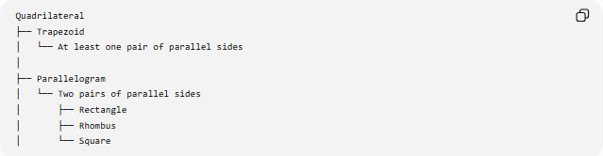
Quadrilateral
├── Trapezoid
│ └── At least one pair of parallel sides
│
├── Parallelogram
│ └── Two pairs of parallel sides
│ ├── Rectangle
│ ├── Rhombus
│ └── Square
The exact definition of trapezoid can vary by convention: some definitions require at least one pair of parallel sides, while others require exactly one pair.

Parallelism in 3D Geometry
# Source: AI Source: Provided by: [Data Path: Persons Table -> ID Column: 1, Name_En Column: Motasem Essam] -> From: [ChatGPT] on [7/25/2026]
In three-dimensional geometry, lines introduce an important distinction.
Two lines can be:
- intersecting
- parallel
- skew
Parallel lines
They lie in the same plane and do not intersect.
$$\boxed{l_{1}∥l_{2}}$$
Skew lines
They do not intersect and are not coplanar.
Therefore:
$$\boxed{\text{Non-intersecting}≠\text{necessarily parallel in 3D}}$$
This is an important difference from plane geometry.

Parallelism Proof Conditions
# Source: AI Source: Provided by: [Data Path: Persons Table -> ID Column: 1, Name_En Column: Motasem Essam] -> From: [ChatGPT] on [7/25/2026]
Parallelism frequently appears as the goal of a geometry proof.
Example
Given:
$$∠A=∠B$$
where the angles are alternate interior angles formed by a transversal.
Goal:
$$\boxed{l_{1}∥l_{2}}.$$
Reason:
Converse of the Alternate Interior Angles Theorem.
Another proof method
Using slopes:
$$m_{1}=m_{2}.$$
Therefore:
$$\boxed{l_{1}∥l_{2}}.$$
Thus parallelism can be established through:
- angle relationships
- slopes
- vectors
- coordinates
- geometric theorems
- transformations

Multiple Parallelism Conditions
# Source: AI Source: Provided by: [Data Path: Persons Table -> ID Column: 1, Name_En Column: Motasem Essam] -> From: [ChatGPT] on [7/25/2026]
Definition
A Multiple Parallelism Condition requires several objects to be parallel simultaneously.
Example
Suppose:
$$l_{1}∥l_{2}$$
and:
$$l_{2}∥l_{3}.$$
Then:
$$\boxed{l_{1}∥l_{3}}$$
provided the lines are distinct and in the appropriate Euclidean configuration.
Family of parallel lines
A collection such as:
$$l_{1}∥l_{2}∥l_{3}∥l_{4}$$
forms a family of parallel lines.

19. Combined Parallelism Conditions
# Source: AI Source: Provided by: [Data Path: Persons Table -> ID Column: 1, Name_En Column: Motasem Essam] -> From: [ChatGPT] on [7/25/2026]
Definition
A Combined Parallelism Condition combines parallelism with other geometric requirements.
Example
A point $P$must lie on a segment and a line through $P$must be parallel to another line:
$$P∈\overset{‾}{AB}$$
and:
$$l_{P}∥l.$$
The complete condition is:
$$\boxed{P∈\overset{‾}{AB}∧l_{P}∥l}$$
Another example
A point must be equidistant from two parallel lines:
$$d\left(P , l_{1}\right)=d\left(P , l_{2}\right)$$
with:
$$l_{1}∥l_{2}.$$
The resulting locus is the line halfway between $l_{1}$and $l_{2}$, parallel to both.

Parallelism and Loci
# Source: AI Source: Provided by: [Data Path: Persons Table -> ID Column: 1, Name_En Column: Motasem Essam] -> From: [ChatGPT] on [7/25/2026]
Parallelism conditions can define loci.
Example
Given a line $l$and a point $P$, the set of all lines through $P$parallel to $l$consists of exactly one line in Euclidean plane geometry.
$$\boxed{∃! l^{'}\text{ through }P\text{ such that }l^{'}∥l}$$
This expresses the parallel postulate.
Fixed-distance locus
Given a line $l$, the set of points at a fixed perpendicular distance $r$from $l$consists of two parallel lines:
$$\boxed{d\left(P , l\right)=r}.$$
Thus:
$$\boxed{\text{Distance Condition}→\text{Parallel Locus}}$$
in this situation.

Parallelism and Distance
# Source: AI Source: Provided by: [Data Path: Persons Table -> ID Column: 1, Name_En Column: Motasem Essam] -> From: [ChatGPT] on [7/25/2026]
For two parallel lines:
$$l_{1}∥l_{2},$$
the perpendicular distance between them is constant.
If:
$$P,Q∈l_{1}$$
and $P^{'},Q^{'}∈l_{2}$with:
$$PP^{'}⊥l_{1}, QQ^{'}⊥l_{1},$$
then:
$$\boxed{PP^{'}=QQ^{'}}.$$
This constant-distance property is one of the key geometric characteristics of parallel lines.

Parallelism and Perpendicularity
# Source: AI Source: Provided by: [Data Path: Persons Table -> ID Column: 1, Name_En Column: Motasem Essam] -> From: [ChatGPT] on [7/25/2026]
Parallelism and perpendicularity have an important relationship.
If:
$$l_{1}⊥t$$
and:
$$l_{2}⊥t,$$
then:
$$\boxed{l_{1}∥l_{2}}.$$
Example
If two lines are both perpendicular to the same line in a plane, they are parallel.
This gives a common method for proving parallelism.

Parallelism and Transitivity
# Source: AI Source: Provided by: [Data Path: Persons Table -> ID Column: 1, Name_En Column: Motasem Essam] -> From: [ChatGPT] on [7/25/2026]
Parallelism has a transitive property for lines in the Euclidean plane.
If:
$$l_{1}∥l_{2}$$
and:
$$l_{2}∥l_{3},$$
then:
$$\boxed{l_{1}∥l_{3}}.$$
This allows a chain of parallel relationships to be established.

Important Parallelism Tests
# Source: AI Source: Provided by: [Data Path: Persons Table -> ID Column: 1, Name_En Column: Motasem Essam] -> From: [ChatGPT] on [7/25/2026]
There are several major ways to establish:
$$l_{1}∥l_{2}.$$
Test 1 — Equal corresponding angles
$$\boxed{∠1=∠2}$$
Test 2 — Equal alternate interior angles
$$\boxed{∠3=∠4}$$
Test 3 — Supplementary same-side interior angles
$$\boxed{∠5+∠6={180}^{∘}}$$
Test 4 — Equal slopes
$$\boxed{m_{1}=m_{2}}$$
for distinct non-vertical lines.
Test 5 — Parallel direction vectors
$$\boxed{\vec{u}=k\vec{v}}.$$
Test 6 — Both perpendicular to the same line
$$l_{1}⊥t, l_{2}⊥t$$
therefore:
$$\boxed{l_{1}∥l_{2}}.$$

Parallelism vs Perpendicularity
# Source: AI Source: Provided by: [Data Path: Persons Table -> ID Column: 1, Name_En Column: Motasem Essam] -> From: [ChatGPT] on [7/25/2026]
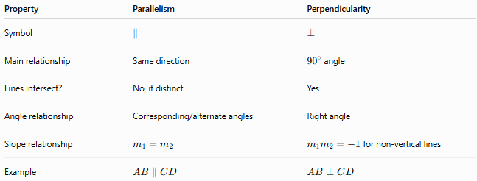
Property | Parallelism | Perpendicularity
Symbol | $$∥$$ | $$⊥$$
Main relationship | Same direction | ${90}^{∘}$angle
Lines intersect? | No, if distinct | Yes
Angle relationship | Corresponding/alternate angles | Right angle
Slope relationship | $$m_{1}=m_{2}$$ | $m_{1}m_{2}=-1$for non-vertical lines
Example | $$AB∥CD$$ | $$AB⊥CD$$
Parallelism describes directional alignment, while perpendicularity describes a right-angle relationship.

Parallelism vs Equality
# Source: AI Source: Provided by: [Data Path: Persons Table -> ID Column: 1, Name_En Column: Motasem Essam] -> From: [ChatGPT] on [7/25/2026]
Parallelism does not mean equal length.
For example:
$$AB=5, CD=10$$
and:
$$AB∥CD$$
can both be true.
Therefore:
$$\boxed{\text{Parallel}≠\text{Equal Length}}$$
However, certain figures can have both properties.
For example, in a parallelogram:
$$AB∥CD$$
and:
$$AB=CD.$$

Coordinate Formulas
# Source: AI Source: Provided by: [Data Path: Persons Table -> ID Column: 1, Name_En Column: Motasem Essam] -> From: [ChatGPT] on [7/25/2026]
Slope
For:
$$A=\left(x_{1} , y_{1}\right), B=\left(x_{2} , y_{2}\right),$$
the slope is:
$$\boxed{m=\frac{y_{2}-y_{1}}{x_{2}-x_{1}}}$$
when $x_{2}≠x_{1}$.
Parallel lines satisfy:
$$\boxed{m_{1}=m_{2}}.$$
General equation
For:
$$a_{1}x+b_{1}y+c_{1}=0$$
and:
$$a_{2}x+b_{2}y+c_{2}=0,$$
the lines are parallel when their normal vectors are proportional:
$$\boxed{\left(a_{1} , b_{1}\right)=k\left(a_{2} , b_{2}\right)}$$
for some nonzero $k$, with the lines distinct.

Key Formulas
# Source: AI Source: Provided by: [Data Path: Persons Table -> ID Column: 1, Name_En Column: Motasem Essam] -> From: [ChatGPT] on [7/25/2026]
Basic parallelism
$$\boxed{l_{1}∥l_{2}}$$
No intersection
$$\boxed{l_{1}∩l_{2}=∅}$$
for distinct parallel lines in the Euclidean plane.
Equal slopes
$$\boxed{m_{1}=m_{2}}$$
Vector condition
$$\boxed{\vec{u}=k\vec{v}}$$
2D vector determinant
$$\boxed{u_{1}v_{2}-u_{2}v_{1}=0}$$
Parallel-line angle conditions
$$\boxed{\text{Corresponding angles are equal}} \\ \boxed{\text{Alternate interior angles are equal}} \\ \boxed{\text{Alternate exterior angles are equal}} \\ \boxed{\text{Same-side interior angles sum to }{180}^{∘}}$$
Perpendicular test
$$\boxed{l_{1}⊥t, l_{2}⊥t⇒l_{1}∥l_{2}}$$

Classification Summary
# Source: AI Source: Provided by: [Data Path: Persons Table -> ID Column: 1, Name_En Column: Motasem Essam] -> From: [ChatGPT] on [7/25/2026]
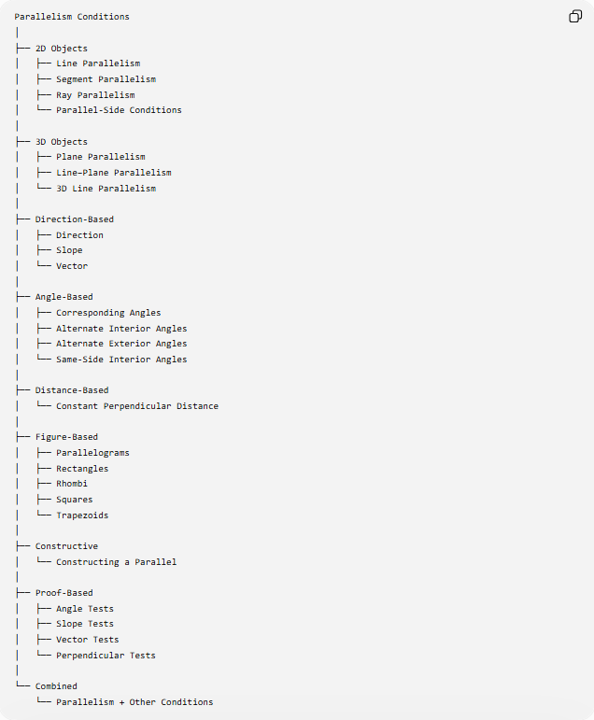
Parallelism Conditions
│
├── 2D Objects
│ ├── Line Parallelism
│ ├── Segment Parallelism
│ ├── Ray Parallelism
│ └── Parallel-Side Conditions
│
├── 3D Objects
│ ├── Plane Parallelism
│ ├── Line–Plane Parallelism
│ └── 3D Line Parallelism
│
├── Direction-Based
│ ├── Direction
│ ├── Slope
│ └── Vector
│
├── Angle-Based
│ ├── Corresponding Angles
│ ├── Alternate Interior Angles
│ ├── Alternate Exterior Angles
│ └── Same-Side Interior Angles
│
├── Distance-Based
│ └── Constant Perpendicular Distance
│
├── Figure-Based
│ ├── Parallelograms
│ ├── Rectangles
│ ├── Rhombi
│ ├── Squares
│ └── Trapezoids
│
├── Constructive
│ └── Constructing a Parallel
│
├── Proof-Based
│ ├── Angle Tests
│ ├── Slope Tests
│ ├── Vector Tests
│ └── Perpendicular Tests
│
└── Combined
└── Parallelism + Other Conditions

Key Points
# Source: AI Source: Provided by: [Data Path: Persons Table -> ID Column: 1, Name_En Column: Motasem Essam] -> From: [ChatGPT] on [7/25/2026]
- Parallelism Conditions require geometric objects to have a parallel relationship.
- The fundamental notation is:
$$\boxed{l_{1}∥l_{2}}.$$
- In plane geometry, distinct parallel lines do not intersect.
- Parallel lines have the same direction and a constant perpendicular distance.
- Equal slopes establish parallelism for distinct non-vertical lines:
$$m_{1}=m_{2}.$$
- Vectors are parallel when one is a scalar multiple of the other:
$$\vec{u}=k\vec{v}.$$
- A transversal provides important angle tests for proving parallelism.
- Two lines perpendicular to the same line are parallel in Euclidean plane geometry.
- Parallelism does not imply equal lengths.
- In 3D geometry, non-intersecting lines are not necessarily parallel because skew lines can exist.
- Parallelism is fundamental to the classification of quadrilaterals such as parallelograms, rectangles, rhombi, squares, and trapezoids.
- Parallelism conditions can be used in proofs, constructions, coordinate geometry, vectors, loci, and spatial geometry.

Conclusion
# Source: AI Source: Provided by: [Data Path: Persons Table -> ID Column: 1, Name_En Column: Motasem Essam] -> From: [ChatGPT] on [7/25/2026]
Parallelism Conditions specify that geometric objects maintain a parallel relationship, usually by sharing the same direction and, for distinct coplanar lines, never intersecting.
The central condition is:
$$\boxed{l_{1}∥l_{2}}$$
and it can be established in several equivalent or related ways:
$$\boxed{\begin{aligned}&\text{Equal slopes} \\ &\text{Parallel direction vectors} \\ &\text{Equal corresponding angles} \\ &\text{Equal alternate interior angles} \\ &\text{Supplementary same-side interior angles} \\ &\text{Both perpendicular to the same line}\end{aligned}}$$
Therefore, parallelism is a fundamental geometric condition connecting direction, angles, distance, perpendicularity, coordinates, vectors, polygons, constructions, loci, and geometric proofs.

